Where are you on the route to implementing the New Illinois Science Standards?

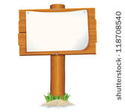

**Previous Illinois Science Standards**



**New Illinois Science Standards**