Mathematics Instructional Design, Delivery and Assessment
Grades 3-5
ISBE Foundational Services

Math Talks:
- What are some components of a Math Talk?

- How do you do a Math Talk?

Illinois Teach and Talk
- www.ilteachandtalk.org
- Take some time to review and then choose a standard and a PowerPoint slideshow
- Pick someone at your table’s to do.

Compare 2/5 2/3
Use a number line or area model to justify your answer.

Resources:
- PARCC Partnership Resource Center – prc.parcconline.org (Code IL1818)
- Jo Boaler video - https://www.youtube.com/watch?v=3icoSeGqQtY
- Grade 5 Re-engagement Lesson http://www.insidemathematics.org/classroom-videos/formative-re-engaging-lessons/5th-grade-math-interpreting-fractions/lesson-part-1
- Grade 3 Number Talk: http://www.mathsolutions.com/videopage/videos/Final/Classroom_NumberTalk_Gr3.swf
- Implementation Guides http://www.ilclassroomsinaction.org/implementation-guides-for-math.html
- Number Talks – Helping Children Build Mental Math and Computation Strategies (K-5), by Sherry Parrish
- Making Number Talks Matter – Developing Mathematical Practices and Deepening Understanding, Grades 4-10, by Cathy Humphreys & Ruth Parker
Planning a Number Talk – Appendix A Making Math Talks Matter
By Cathy Humphreys & Ruth Parker

Anticipate different strategies | Recording methods
Questions for students | Reflections

Number Talks (3rd Grade VF654116): Notes:

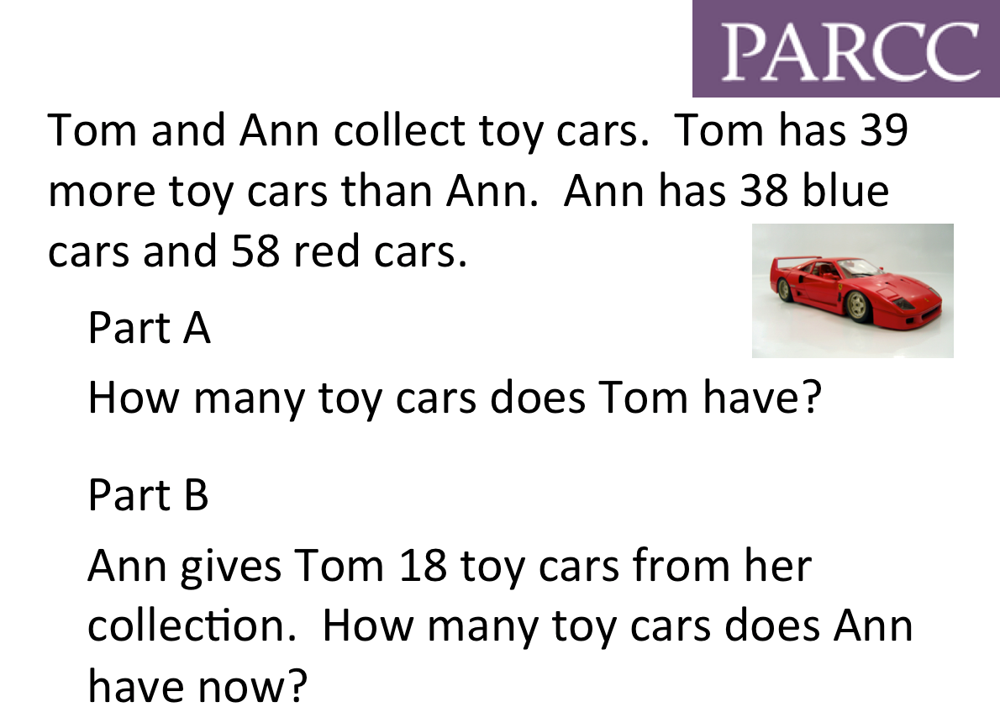

Create your own Math Talk Based on a PARCC Problem and an upcoming lesson in your class.
  - Share with a partner
  - Make sure all components are present.
  - Think about, reflect or practice how you will facilitate this problem.

Re-Engagement Lesson (Grade 4 M02080): Notes:

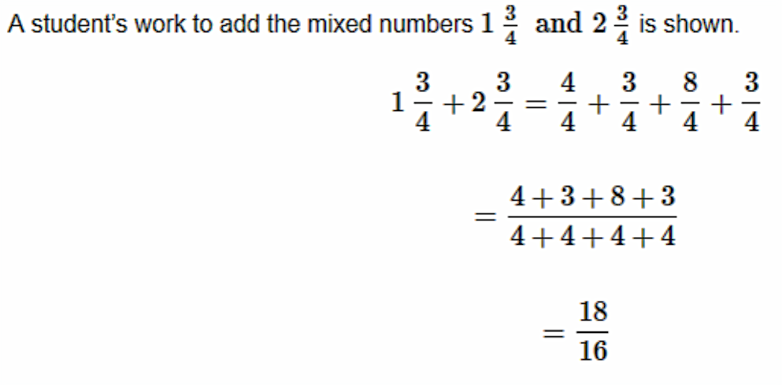

Explain any errors you see in the work. Find the correct
solution. Show your work or explain your answer.

Student 1:
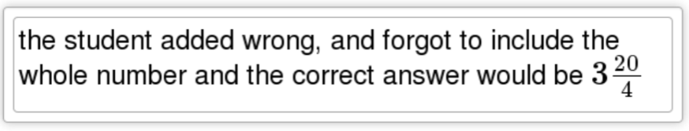

Student 2:

Student 3:
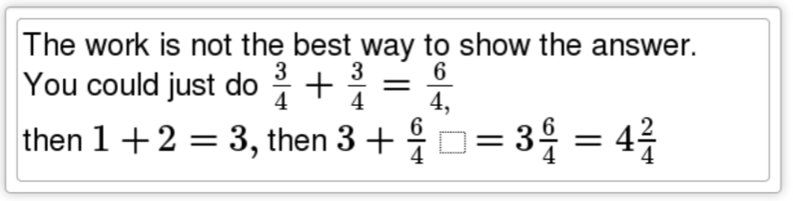

Student 4:
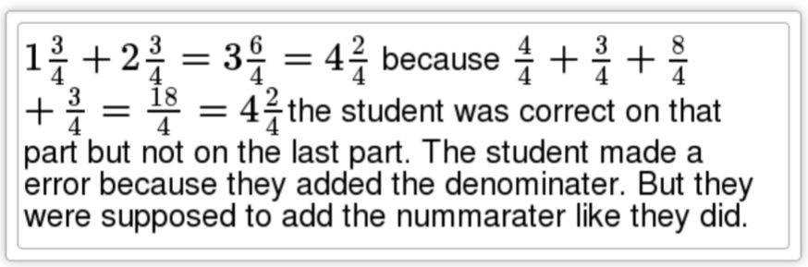

Create your own Re-engagement Lesson based on a PARCC Problem and an upcoming lesson in your classroom:
- Share with a partner
- Think about, reflect or practice how you will facilitate this problem

