Foundational Services Actual Attendance and Required Forms:
The following guide can be used to view and print two standard reports from ABC Signup AND enter in actual number of attendees at training sessions. Recorded live webinar with questions can be accessed here https://drive.google.com/file/d/0BzslvvzBhsQdZlFUN0NjTlhkY0U/view?usp=sharing

Log into ABC Signup:  Go to https://admin.abcsignup.com  Account Code i-kan  Username  Password abc12345  Note: If your office is using the full version of ABC Signup, please use your current username/password | 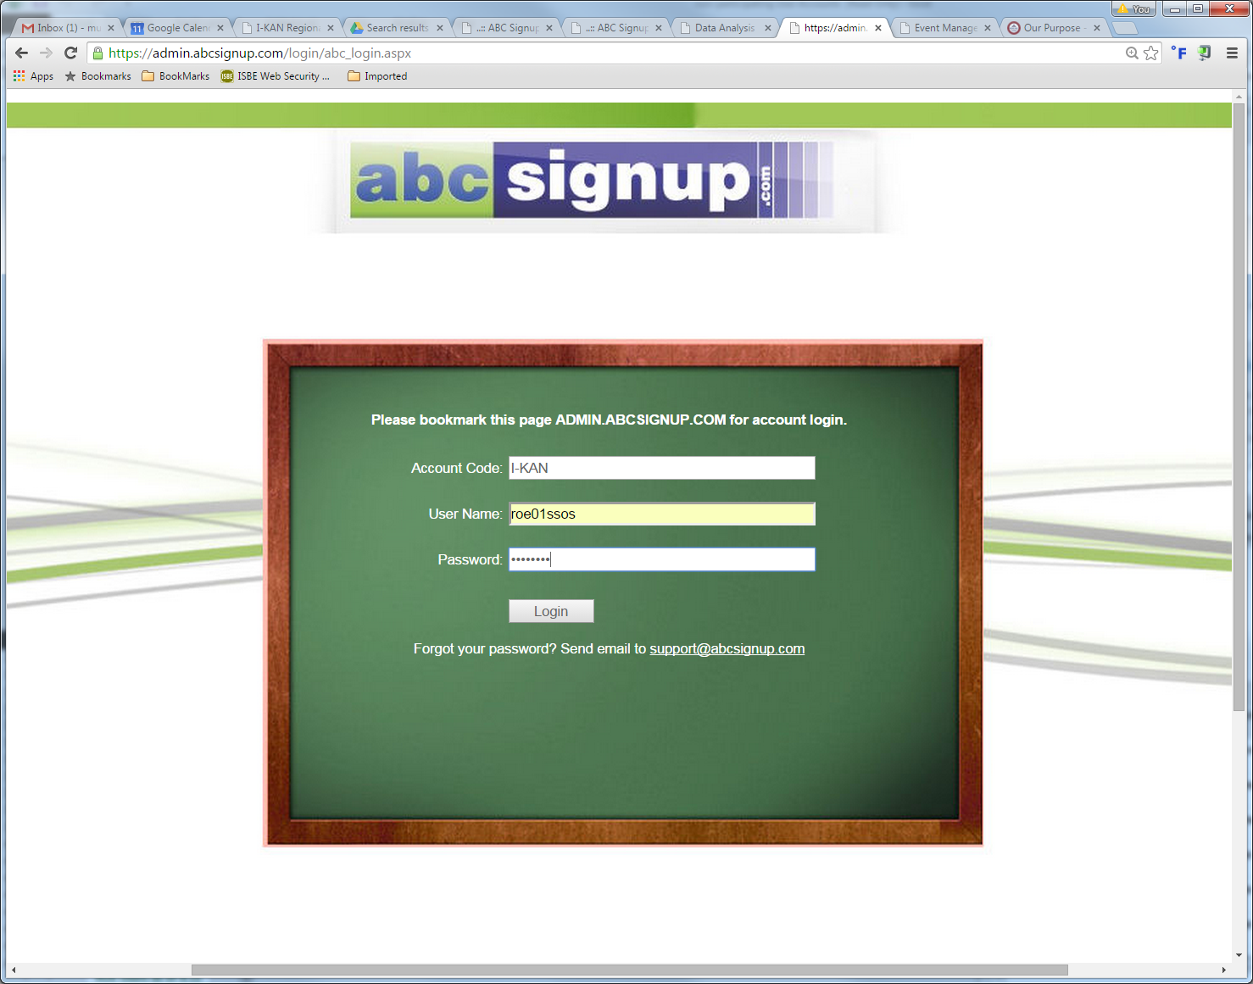
Find the Event  Select “Past Events” at the top of the page  Click “Date” to sort the list chronologically  Click on the event line | 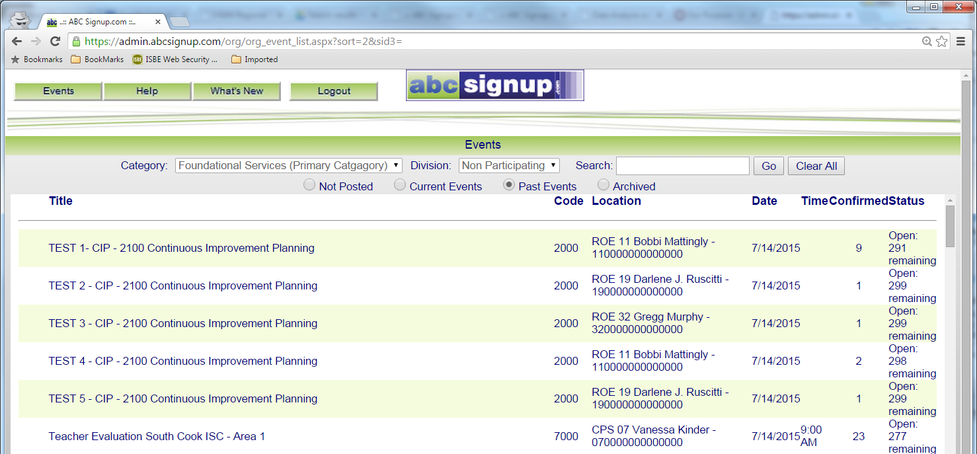  Date  Past Events
Click the Reports Icon | 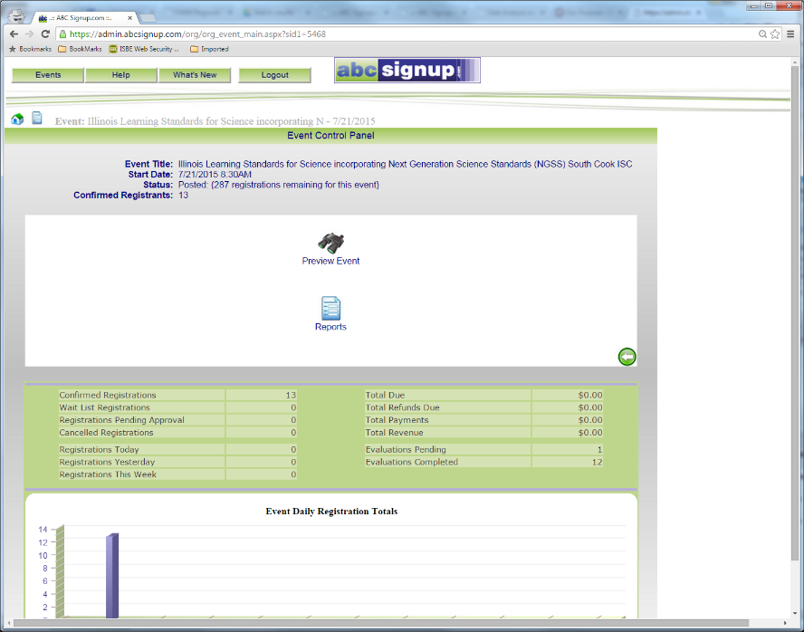  Reports Icon
Find the Report  Expand “Forms” by selecting the “+” to the left | Forms
Select the Report  Select “Sign In Sheet – All”  Suggestion- Print as a record of who has evaluated the course | 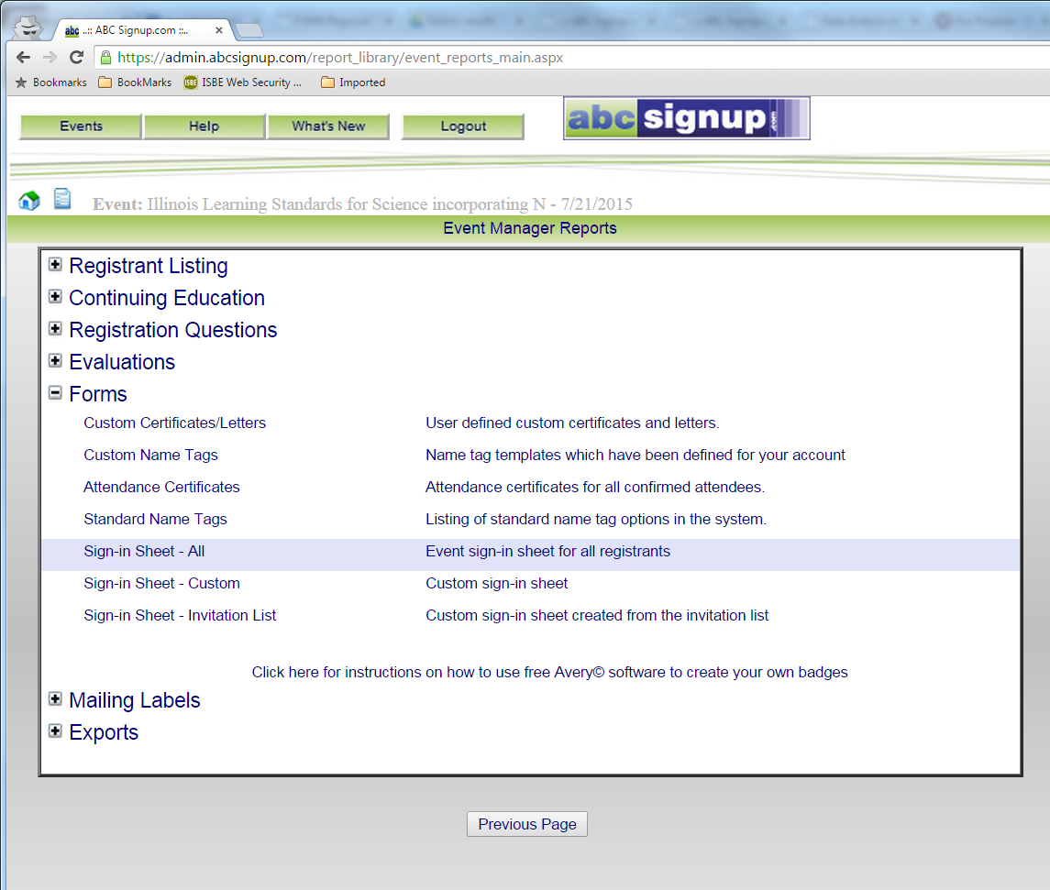  Sign In Sheet - All
Select Evaluation Summary  Expand “Evaluations” by selecting the “+” to the left  Click PDF link for “Evaluation Summary Report” | 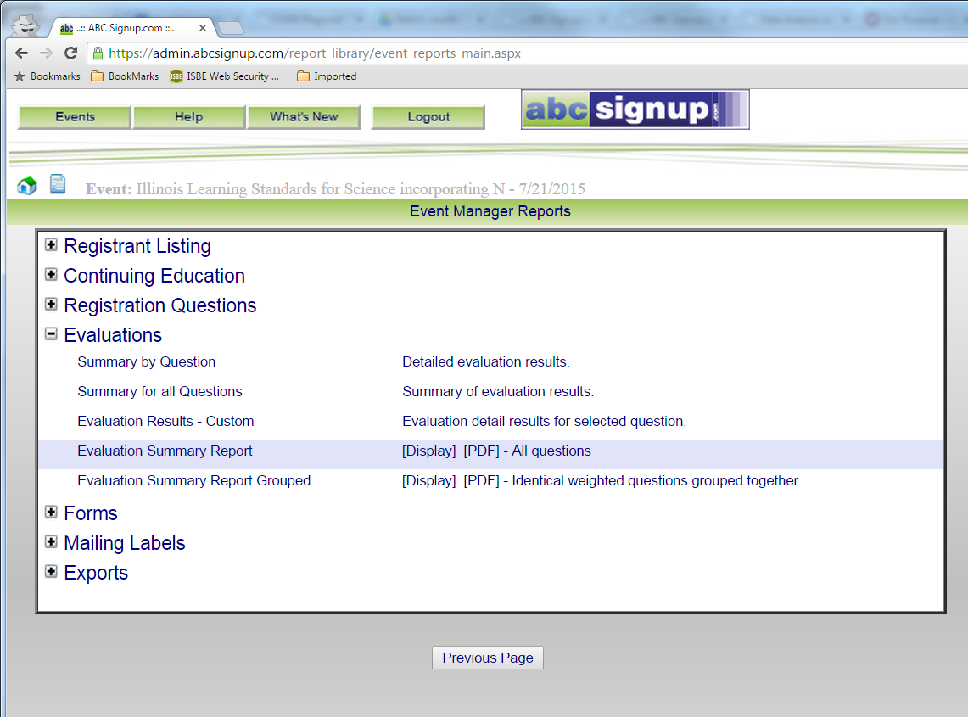  PDF  Evaluation Summary Report
Enter Total Participants  Expand “Custom Reports/Exports by selecting the “+” to the left  Click on “Enter Actual Attendance”  Enter the number of attendees and click on “save changes” | 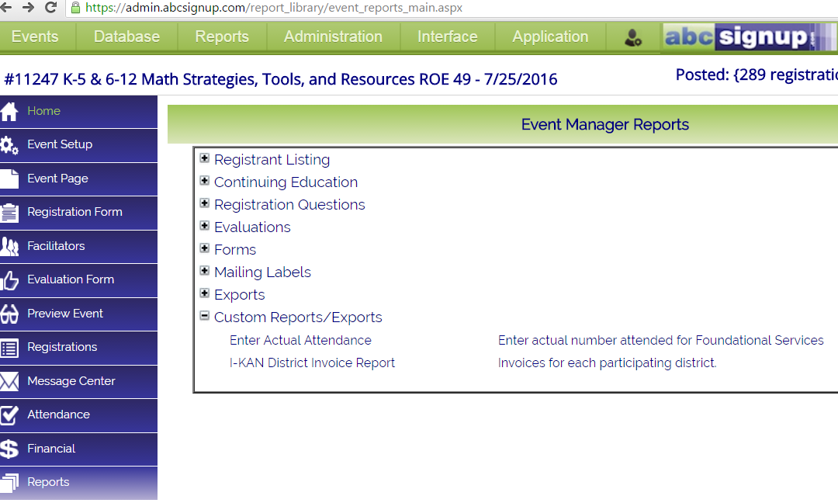––--  Custom Reports/Exports  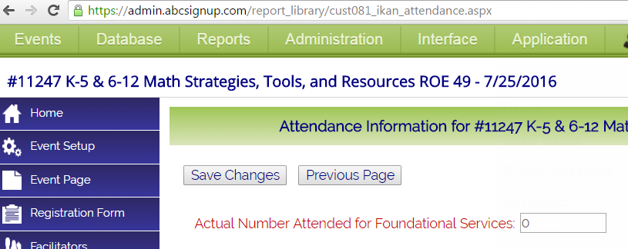  Enter the # of attendees and then save changes

FAQ on the following pages

FAQ from the live webinar 8/17/16

Is entering the actual attendance number mandatory for each session since this information is entered in Service Tracker?
- Yes; while duplicative information, our hope is that we can show, through FY17 that one system is capable of reporting ALL of the necessary data in one system for FY18 and beyond.

Do we still need to enter all other information in Service Tracker?
- Yes; we need a full year of clean data in both systems to prove we don't need two systems

Do we need to backtrack past presentations to July 1, 2016?
- Yes; if your office has difficulty doing this, please contact Suzy Dees at deess@roe17.org. Please also make this part of your protocol when entering Service Tracker and ABC Sign-up (evaluation) data for each entry moving forward.

When entering the unregistered participant information, will we need to add information other than the total number of attendees? (e.g. SD#, Name, etc.)
- No; the only new ask is to enter the actual attendance in ABC Signup in addition to the information already entered for both Service Tracker and ABC Signup

If we are responsible for keeping sign-up sheets, evaluation information, and evidence of completion sheets for every workshop offered, how can we easily print those off from the system since our participants each print off their own copies?
- See additional attached document titled Printing Sample Evidence of Completion Report

If we already have a sign-in sheet we use in our office (not from ABC Signup), do we still need to print one from ABC for audit purposes?
- No, the feature shown today is simply a way, for your office, to show that the people who requested an evaluation actually attended the training. This is in response to those who were concerned, in the beginning, about potential fraud of those completing evaluations and getting evidence of completion forms who did not actually attend sessions.
How many offices are currently using the full ABC Signup package?
- Nine

When does a workshop close (when can participants no longer complete an evaluation?
- Training Registration/evaluation remains active for 1 year from the date it was requested. The exception to this is on July 10 (or near that) all previous fiscal year trainings are archived and end of year reports are generated.

