Foundational Services Reports Available:
The following guide can be used to:
- Print Sample Evidence of Completion Report
Log into ABC Signup:  Go to https://admin.abcsignup.com  Account Code i-kan  Username  Password abc12345  Note: If your office is using the full version of ABC Signup, please use your current username/password | 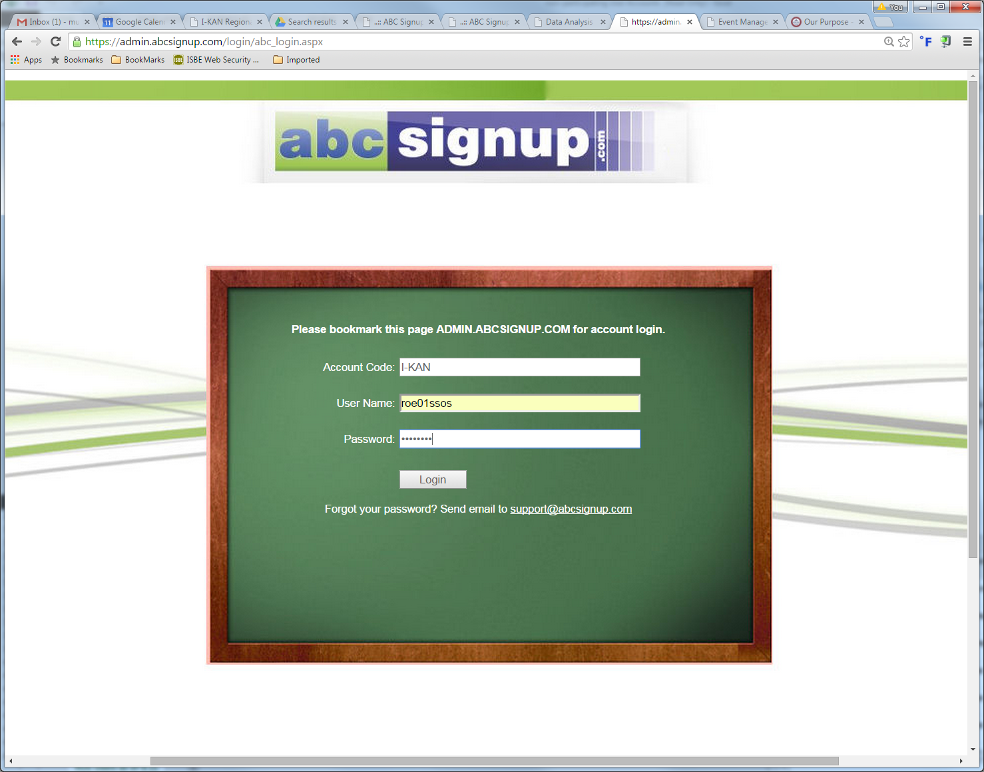
Find the Event  Select “Past Events” at the top of the page  Click “Date” to sort the list chronologically  Click on the event line | 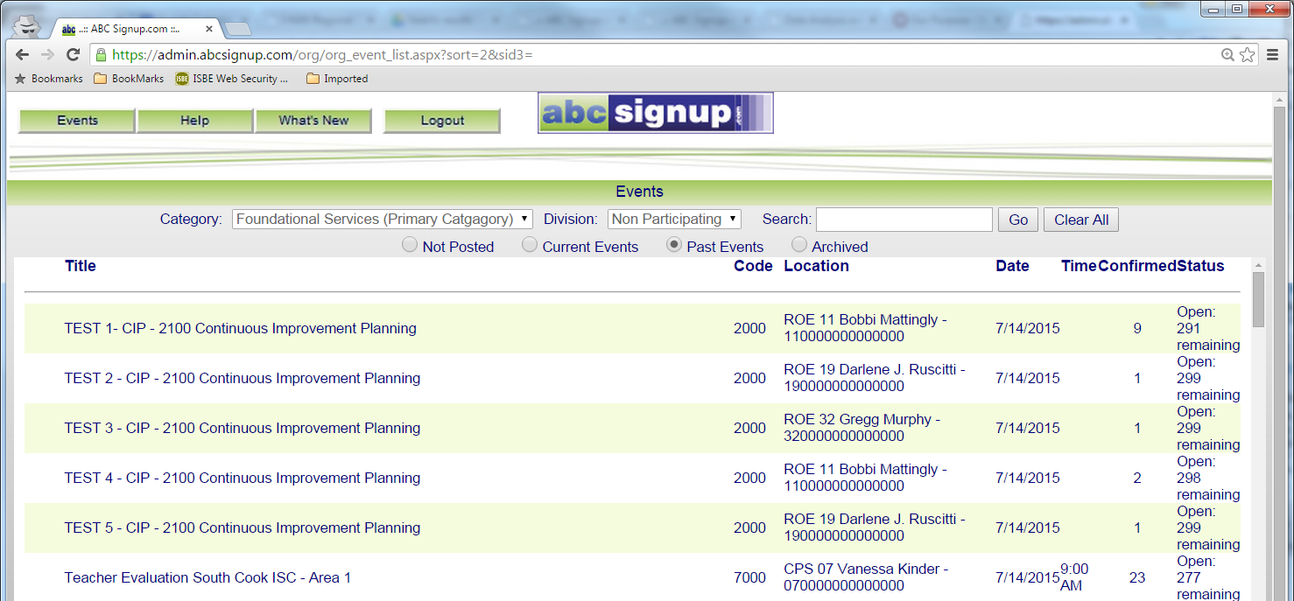  Date  Past Events
Click the Reports Icon | 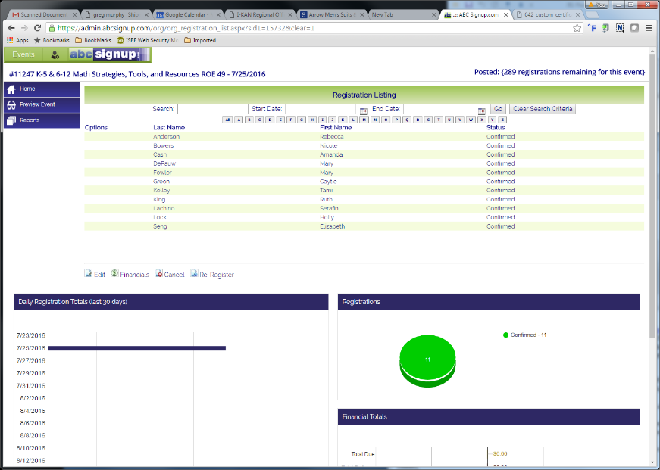  Reports Icon
Find the Report  Expand “Forms” by selecting the “+” to the left | Forms
Select the Report  Select “Custom Certificates/Letters” | 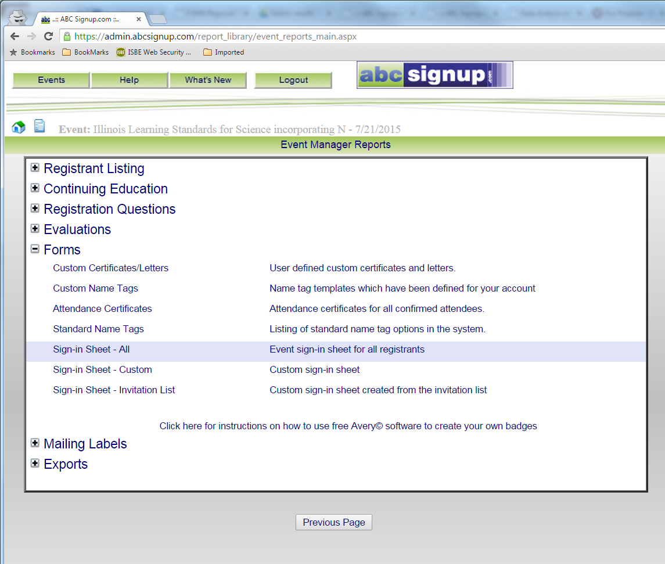  Custom Certificates/Letters
Select “Print Certificates | 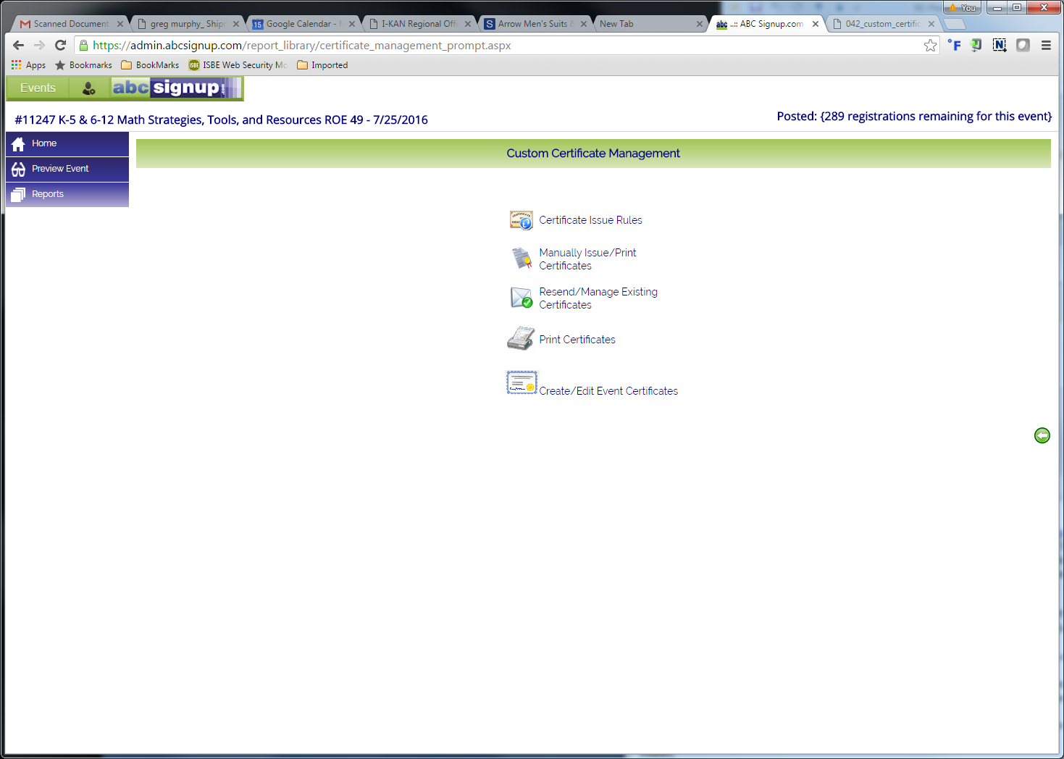  Print Certificates
Click Continue with no data entry required | 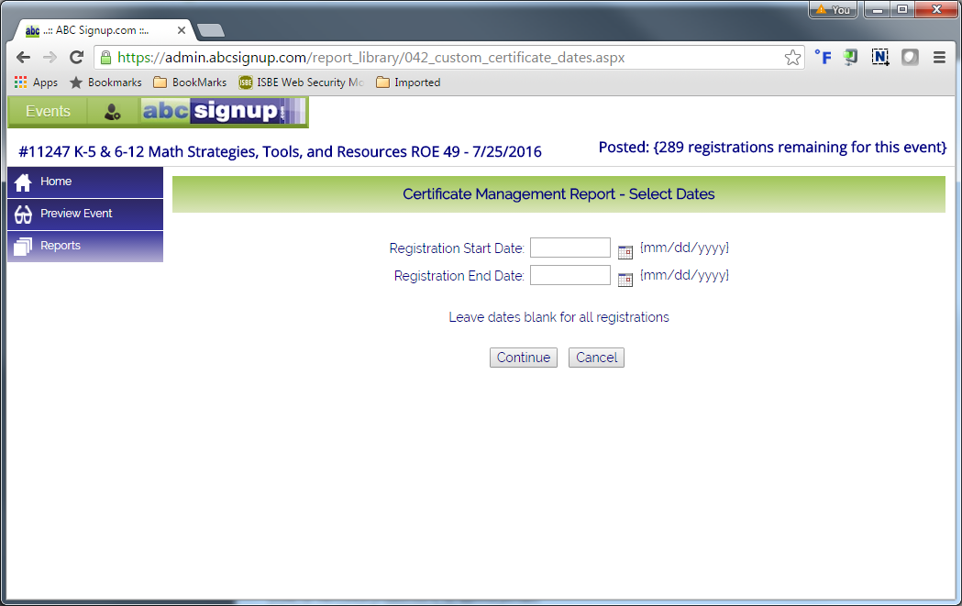  Continue
Select a participant  Click “Generate Certificates/Letters | 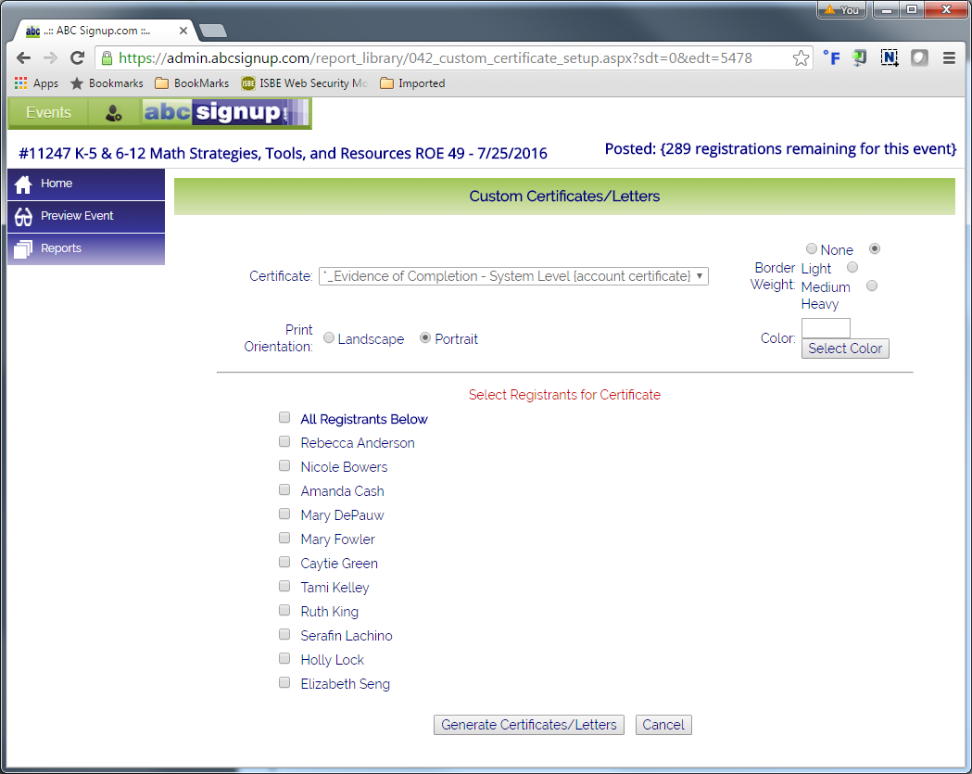  Generate Certificates/Letters  Select a participant
Print an Evidence of Completion form as a sample for the office files. | 