Where are you on the route to Three Dimensional Instruction and Learning?

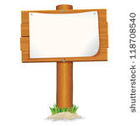

**Current Science Instruction**



**Three Dimensional Learning**