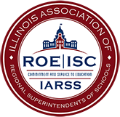
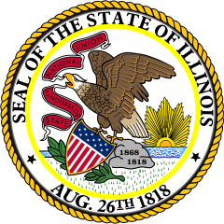
ILLINOIS
STATEWIDE SYSTEM OF SUPPORT FOUNDATIONAL SERVICES
(Title of Event)

Who:

When:

Where:

Presenters:

Outcomes and Description:

Contact your ROE/ISC to register.
This program is fully (100%) funded by the United States Department of Education using No Child Left Behind, Title I Part A Funds, through a grant from the Illinois State Board of Education, Statewide System of Support funds.

