**Temperature Check**

**On a scale of 1-5, what is your current confidence level with Continuous Improvement Planning utilizing Rising Star?**

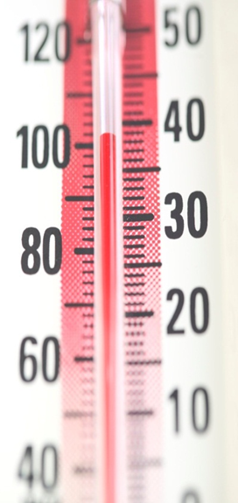

**1 2 3 4 5**

**Low - Confidence Level - High**

Uncomfort Highable