Kindergarten- Illustrated Mathematics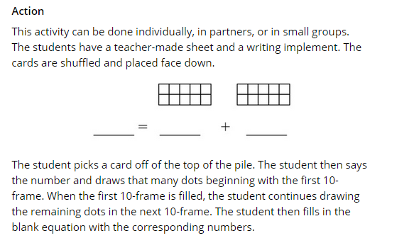

2nd Grade- LiveBinder Illinois Model Math Resources
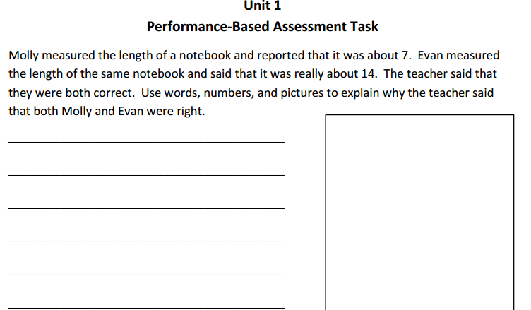

3rd Grade- Achieve the Core
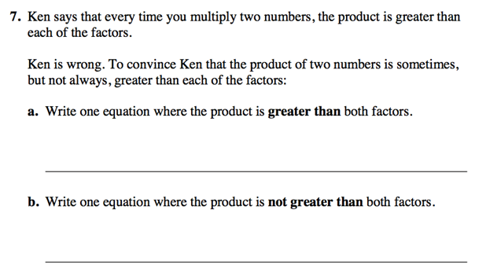

5th Grade- IL Teach and Talk
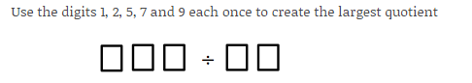

6th Grade- Livebinder Illinois Model Math Resources
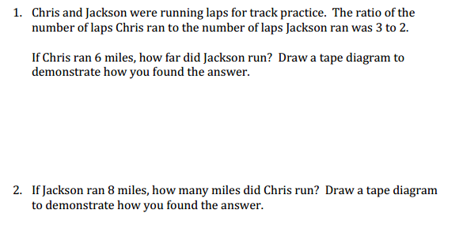

8th Grade- EngageNY
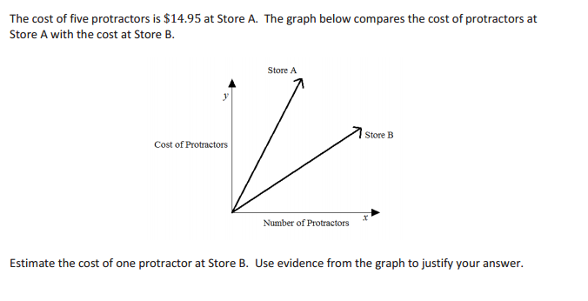

High School – Mathematics Vision Project
For each real-world context or circumstance determine the center of dilation and the tool being used to do the dilation.

