**Fractions: Equivalence and Operations**

**Measuring Fish**

Objectives:

1. *Student can collect data by measuring objects to the nearest 1/8 of an inch.*
2. *Student can create a line plot from the data they collected.*
3. *Student can solve problems, using addition and subtractions of fractions, by using data from a line plot.*

Materials:

Fish Pictures (1 copy per student)

Measuring Fish Assessment Sheet (1 copy per student)

Rulers – Must have 1/8 inch markings

Self-assessment checklist

Task Description:

1. Measure each fish on the Fish Pictures worksheets to the nearest eighth of an inch.
2. Record the data in the table on the Measuring Fish Assessment Sheet.
3. Using the data table, create a line plot.
4. Use the line plot to complete the Measuring Fish Assessment Sheet.

TEACHER NOTE:

A blank number line has been provided on the Assessment Sheet as an optional tool to help students use equivalent fractions to add and subtract with unlike denominators, where one denominator is a multiple of the other**. Before giving this assessment, students should have practiced this skill during instruction.**

C:\Documents and Settings\jkurtsi1\Local Settings\Temporary Internet Files\Content.IE5\7UL3YW7W\MC900383368[1].wmf**Name: _________________________**

**Measuring Fish Assessment Sheet**

**Measure the length of each fish to the nearest $\frac{1}{8}$ inch.**

**Record the data in the table.**

|  |  |  |  |  |  |  |  |  |  |  |  |
| --- | --- | --- | --- | --- | --- | --- | --- | --- | --- | --- | --- |
| **Fish** | **1** | **2** | **3** | **4** | **5** | **6** | **7** | **8** | **9** | **10** | **11** |
| **Length** |  |  |  |  |  |  |  |  |  |  |  |

**Make a line plot to display the data on the table.**

|  |  |  |  |  |  |  |  |  |  |  |  |  |  |  |  |  |  |  |  |  |  |  |  |  |  |  |  |  |  |  |  |  |  |  |  |  |  |  |  |  |  |  |  |  |  |
| --- | --- | --- | --- | --- | --- | --- | --- | --- | --- | --- | --- | --- | --- | --- | --- | --- | --- | --- | --- | --- | --- | --- | --- | --- | --- | --- | --- | --- | --- | --- | --- | --- | --- | --- | --- | --- | --- | --- | --- | --- | --- | --- | --- | --- | --- |
|  |  | | |  | |  | |  | |  | |  | |  | |  | |  | |  | |  | | |  | | |  | | |  | | |  | | |  | |  | | |  | | |  |
|  |  | | |  | |  | |  | |  | |  | |  | |  | |  | |  | |  | | |  | | |  | | |  | | |  | | |  | |  | | |  | | |  |
|  | |  |  | |  | |  | |  | |  | |  | |  | |  | |  | |  | |  |  | |  |  | |  |  | |  |  | |  |  | |  | |  |  | |  |  | |

**Optional Tool:**

|  |  |  |  |  |  |  |  |  |  |  |  |  |  |  |  |  |  |  |  |
| --- | --- | --- | --- | --- | --- | --- | --- | --- | --- | --- | --- | --- | --- | --- | --- | --- | --- | --- | --- |
|  |  |  |  |  |  |  |  |  |  |  |  |  |  |  |  |  |  |  |  |
|  |  |  |  |  |  |  |  |  |  |  |  |  |  |  |  |  |  |  |  |

**Solve. Use the space provided to show your work.**

|  |  |
| --- | --- |
| Place your answer here.  _____________ | What is the difference between the shortest fish and the longest fish? |

|  |  |
| --- | --- |
| Place your answer here.  _____________ | If you put the three longest fish end to end, what would the total length be? |

|  |  |
| --- | --- |
| Place your answer here.  _____________ | Kim has a fish and places it next to the #10 fish you measured. Kim’s fish is 2 $\frac{1}{4}$ inches long. How long are the two fishes together? |

|  |  |
| --- | --- |
| Place your answer here.  _____________ | Darnell said the longest fish he measured was 5 $\frac{1}{2}$ inches long. What is the length of the largest fish you measured?__________  How many more inches longer is Darnell’s fish? |

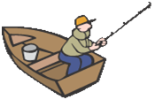

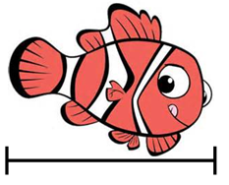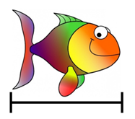

1

http://ts4.mm.bing.net/th?id=H.4884929488094975&pid=1.7

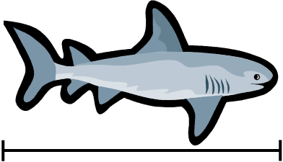

4

3

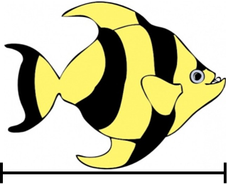

2

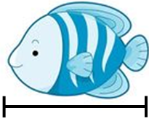

5

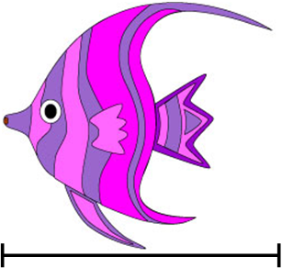

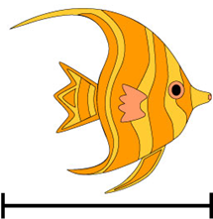

6

10

http://ts4.mm.bing.net/th?id=H.4884929488094975&pid=1.7

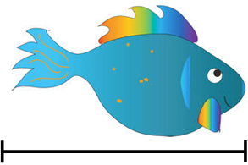

8

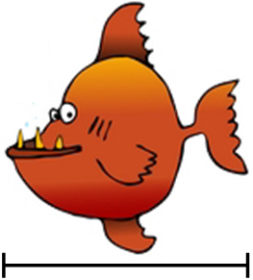

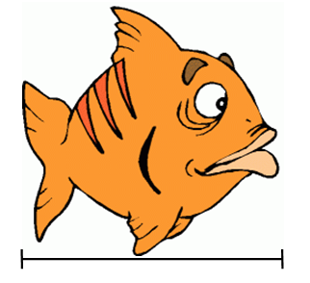

9

11

7



**Name: _________________________**

**Measuring Fish Assessment Sheet ANSWER SHEET**

**Measure the length of each fish to the nearest $\frac{1}{8}$ inch.**

**Record the data in the table.**

|  |  |  |  |  |  |  |  |  |  |  |  |
| --- | --- | --- | --- | --- | --- | --- | --- | --- | --- | --- | --- |
| **Fish** | **1** | **2** | **3** | **4** | **5** | **6** | **7** | **8** | **9** | **10** | **11** |
| **Length** | $$2\frac{2}{8}$$ | $$3\frac{2}{8}$$ | $$3\frac{6}{8}$$ | $$2\frac{1}{8}$$ | $$2\frac{1}{8}$$ | $$2\frac{2}{8}$$ | $$3\frac{1}{8}$$ | $$2$$ | $$2\frac{2}{8}$$ | $$3\frac{1}{8}$$ | $$2\frac{6}{8}$$ |

**Make a line plot to display the data on the table.**

**X**

**X**

**X**

**X**

**X**

**X**

**X**

**X**

**X**

**X**

|  |  |  |  |  |  |  |  |  |  |  |  |  |  |  |  |  |  |  |  |  |  |  |  |  |  |  |  |  |  |  |  |  |  |  |  |  |  |  |  |  |  |  |  |  |  |
| --- | --- | --- | --- | --- | --- | --- | --- | --- | --- | --- | --- | --- | --- | --- | --- | --- | --- | --- | --- | --- | --- | --- | --- | --- | --- | --- | --- | --- | --- | --- | --- | --- | --- | --- | --- | --- | --- | --- | --- | --- | --- | --- | --- | --- | --- |
|  |  | | |  | |  | |  | |  | |  | |  | |  | |  | |  | |  | | |  | | |  | | |  | | |  | | |  | |  | | |  | | |  |
|  |  | | |  | |  | |  | |  | |  | |  | |  | |  | |  | |  | | |  | | |  | | |  | | |  | | |  | |  | | |  | | |  |
|  | |  | 2 | | $$2\frac{1}{8}$$ | | $$2\frac{2}{8}$$ | | $$2\frac{3}{8}$$ | | $$2\frac{4}{8}$$ | | $2\frac{5}{8}$ | | $$2\frac{6}{8}$$ | | $$2\frac{7}{8}$$ | | 3 | | $$3\frac{1}{8}$$ | |  | $$3\frac{2}{8}$$ | |  | $$3\frac{3}{8}$$ | |  | $$3\frac{4}{8}$$ | |  | $$3\frac{5}{8}$$ | |  | $$3\frac{6}{8}$$ | | $$3\frac{7}{8}$$ | |  | 4 | |  |  | |

**Optional Tool:**

|  |  |  |  |  |  |  |  |  |  |  |  |  |  |  |  |  |  |  |  |
| --- | --- | --- | --- | --- | --- | --- | --- | --- | --- | --- | --- | --- | --- | --- | --- | --- | --- | --- | --- |
|  |  |  |  |  |  |  |  |  |  |  |  |  |  |  |  |  |  |  |  |
|  |  |  |  |  |  |  |  |  |  |  |  |  |  |  |  |  |  |  |  |

**Solve. Use the space provided to show your work.**

|  |  |
| --- | --- |
| Place your answer here. $1\frac{6}{8}$ inches  _____________ | What is the difference between the shortest fish and the longest fish?  Longest fish is $3\frac{6}{8}$ inches. Shortest fish is 2 inches. |

|  |  |
| --- | --- |
| Place your answer here. $10\frac{1}{8}$ inches  _____________ | If you put the three longest fish end to end, what would the total length be? |

|  |  |
| --- | --- |
| Place your answer here. $5\frac{3}{8}$ inches  _____________ | Kim has a fish and places it next to the #10 fish you measured. Kim’s fish is 2 $\frac{1}{4}$ inches long. How long are the two fishes together? |

|  |  |
| --- | --- |
| Place your answer here. $1\frac{6}{8}$ inches longer  _____________ | Darnell said the longest fish he measured was 5 $\frac{1}{2}$ inches long. What is the length of the largest fish you measured? $3\frac{6}{8}$____ inches______  How many more inches longer is Darnell’s fish? $$5\frac{1}{2} - 3\frac{6}{8}= 5\frac{4}{8} - 3\frac{6}{8}=4\frac{12}{8}- 3\frac{6}{8}= 1\frac{6}{8}$$ |